**HOW TO INSTALL COMSOL 5.0 IN MICROSOFT WINDOW 10**

1. The Comsol 5.0 software is Compressed to a single file and Available for Download form CC ftp Site. Extract the Zipped file and run the setup from the extracted folder.

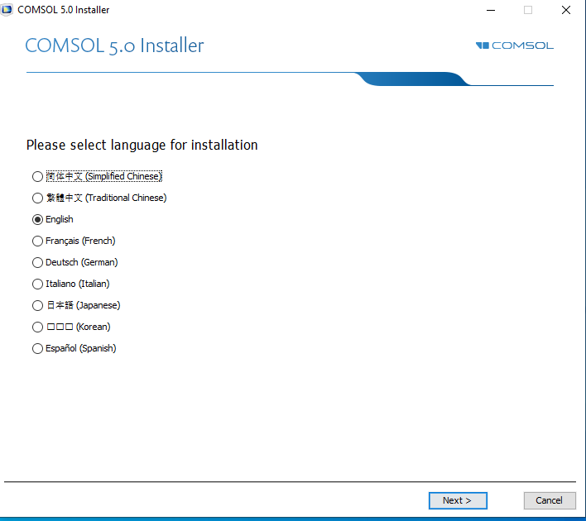

1. Click on the icon “New COMSOL 5.0 Installation”.

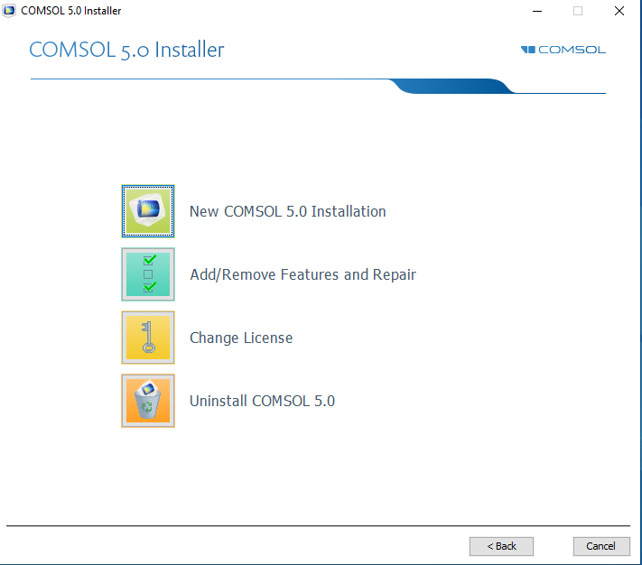

1. Select “I accept the terms in license agreement”. And select the option “<port Number>@<host name>” from the dropdown list of “License format”.

Enter the “Port Number = 1718” and “Host name” = akash2.cc.iitk.ac.in”. Network License server of IIT Campus is akash2.cc.iitk.ac.in”. And click on “Check” button to view the License information.

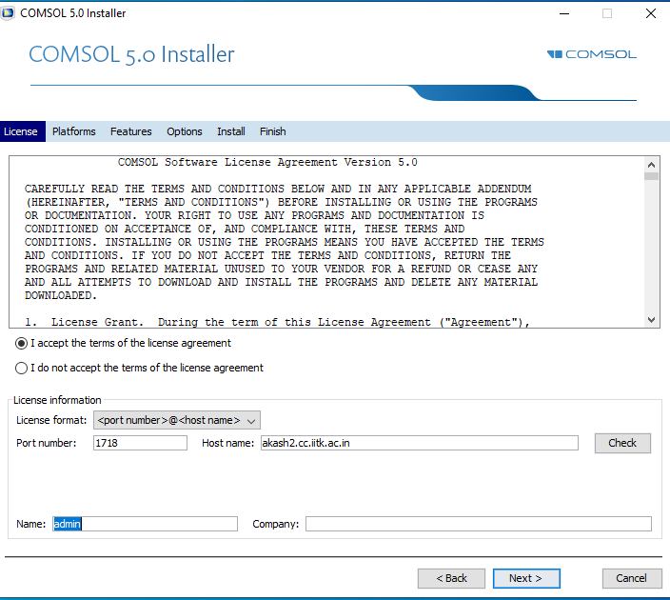

1. Select the proper option according to the Windows Version (32 or 64 bit) and click “Next Button”

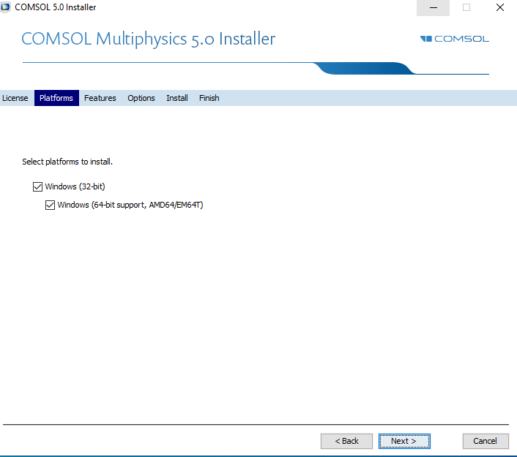

1. Select “Full Installation” from Quick selection dropdown list and remove the check mark from “License Manager”.

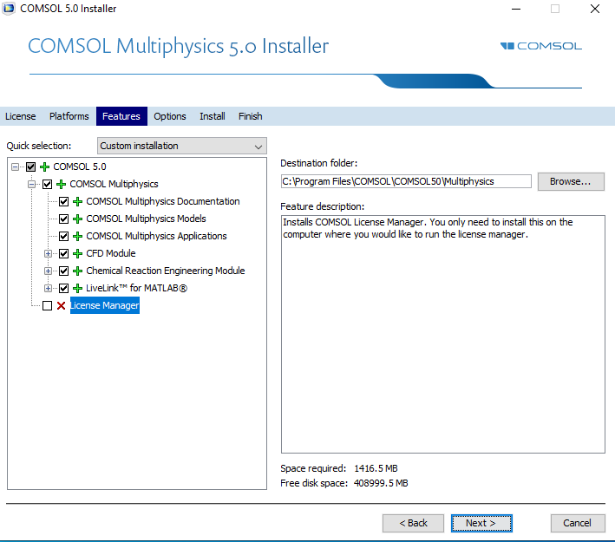

1. If Matlab is installed on the PC, browse to the matlab Installation root. Click on “Next Button.

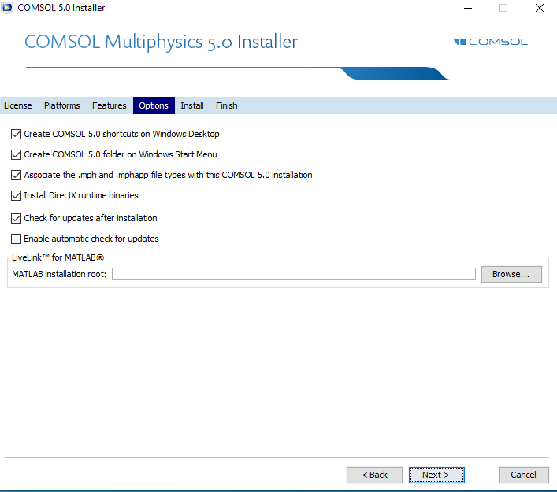

1. Now Click “Install buton”

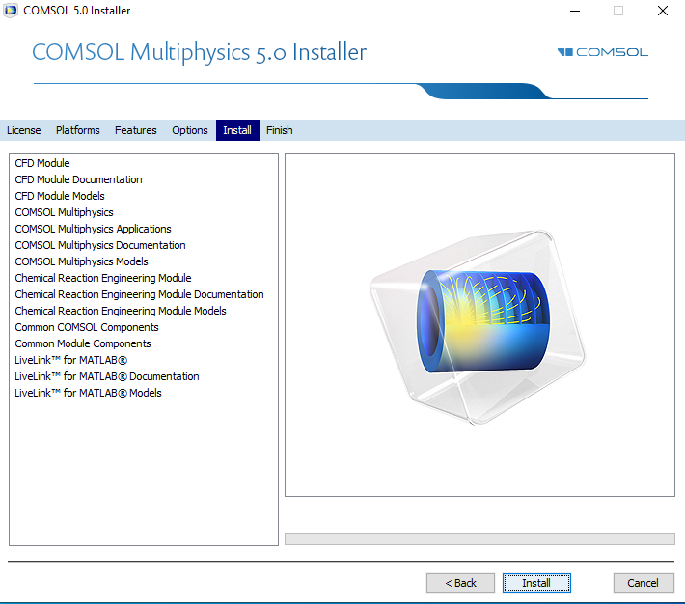

1. Installation Process are Running wait Several minutes.

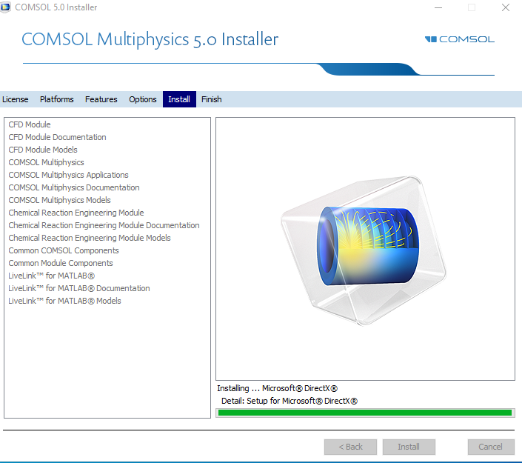

1. Installation Process Completed then Click “finish”.

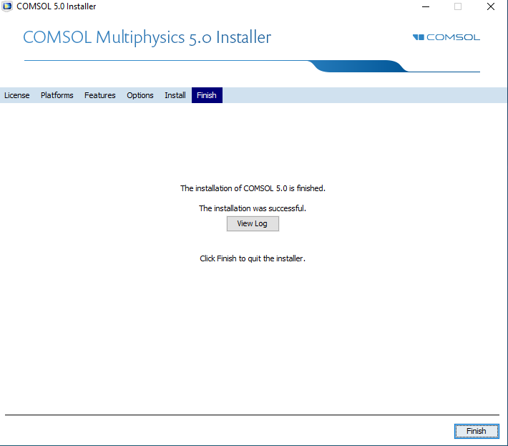

1. Preview of Software as below.

